Nicholas Jurgens

TIM 125

Midterm

Midterm

**Problem 1: Planning**

1. **Define the Problem:**
   1. Create a plan and time-schedule for on the problems below. Also, using an appropriate table (see Problem 6 below), track how well you execute your schedule, and make notes on obstacles and problems that prevent effective execution.
2. **Create a Plan:**
   1. **Step 1:** Clearly state the intent of the midterm.
   2. **Step 2:** Determine the design/development sub-tasks and activities.
   3. **Step 3:** Create a design/development activity matrix purpose to understand the dependencies between the sub-task.
   4. **Step 4:** Create a schedule of tasks using a GANTT chart.
   5. **Step 5:** Identify the “critical path” for the project using PERT chart.
   6. **Step 6:** Create a table and update it with obstacles and problems that occur throughout the project.
3. **Execute:**
   1. **Step 1:** The intent of the midterm is to gain a better understanding of material. In order to do this I need to be able to complete all six problems in a timely manner.
   2. **Step 2:**
      1. **A:** Reading
      2. **B:** Supply Chain Strategy for SPC
      3. **C:** Demand Forecasting for SPC
      4. **D:** Cycle Inventory for Polystyrene at SPC
      5. **E:** Safety Inventory for Polystyrene Resin at SPC
      6. **F:** Execution of Your Plan
   3. **Step 3:** Activity Matrix

|  |  |  |  |  |  |  |
| --- | --- | --- | --- | --- | --- | --- |
|  | **A** | **B** | **C** | **D** | **E** | **F** |
| **A** | **A** |  |  |  |  |  |
| **B** | **X** | **B** |  |  |  |  |
| **C** | **X** |  | **C** |  |  |  |
| **D** | **X** |  | **X** | **D** |  |  |
| **E** | **X** |  | **X** | **X** | **E** |  |
| **F** | **X** | **X** | **X** | **X** | **X** | **F** |

Notation:

X = “depends on”

BxA = subtasks B depends on subtask A

* 1. **Step 4:** GANTT Schedule

|  |  |  |
| --- | --- | --- |
| **Midterm Tasks** | **Start Date** | **Duration (days)** |
| Reading | 2/9/17 | 1 |
| Supply Chain Strategy for SPC | 2/9/17 | 1 |
| Demand Forecasting for SPC | 2/10/17 | 1 |
| Cycle Inventory for Polystyrene at SPC | 2/10/17 | 2 |
| Safety Inventory for Polystyrene Resin at SPC | 2/11/17 | 1 |
| Execution of Your Plan | 2/11/17 | 1 |

* 1. **Step 5:** PERT Chart

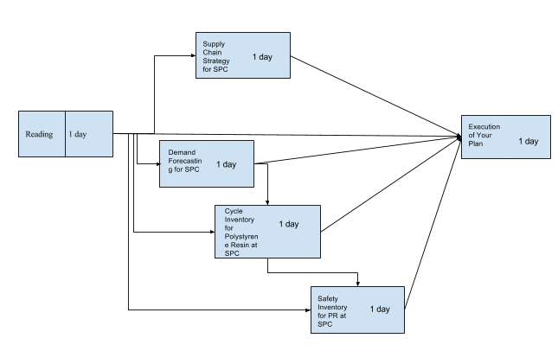

* 1. **Step 6:**

|  |  |
| --- | --- |
| **Problems that occurred** | **Solutions** |
| 2/9/17 Work took up more time than anticipated. | Push back problem 2 |
| 2/10/17 Couldn’t finish problem 3 due to pushing back problem 2. | Push back problem 3 |
| 2/11/17 I was able to finish problem 4 due to lack on information. | Re-read chapter ten and take notes on equations. |
| 2/11/17 Problem 5 and 6 pushed back as well due to pushing back the other problems. | Finish them the following day. |

1. **Draw Conclusions:**
   1. I plan to have this project done by the end of Saturday. I am trying to prioritize my time because I also have to manage my job at Pizza My Heart. The goal is to work hard for several days.

**Problem 2: Supply Chain Strategy for SPC**

1. **Define the Problem:** 
   1. What should SPC’s competitive strategy be? What should SPC’s supply chain strategy be to align with its competitive? Where does SPC lie in the zone of strategic fit between IDU and responsiveness? What should SPC’s high-level SC strategy be for each of the supply chain drivers?
2. **Create a Plan:**
   1. **Step 1:** 
      1. Understand the customer needs
      2. Determine where the product lies in its market life cycle
      3. Determine the IDU for the product and place it on the IDU spectrum
   2. **Step 2:**
      1. For the given product establish the competitive strategy. We can do this by creating a 2x2 grid and showing what their strategy should be.
      2. Determine the trade-off between responsiveness and efficiency for the product based on the competitive strategy.
      3. Map the responsiveness/efficiency trade-off onto a responsiveness/efficiency spectrum.
   3. **Step 3:** 
      1. Create a 2-D space
         1. IDU spectrum is the x-axis
         2. Responsiveness/efficiency spectrum is the y-axis.
      2. Define a zone of strategic fit in this space.
      3. Map the SC strategy for the product in the zone of strategic fit.
   4. **Step 4:** 
      1. Create a diagram of the five SC drivers for SPC.
      2. Explain each driver.
3. **Execute:**
   1. **Step 1:**
      1. Customer Needs
         1. Meet demand
         2. Recyclable/disposable
         3. Clear Plastic Containers
         4. Black plastic containers
      2. Market life cycle

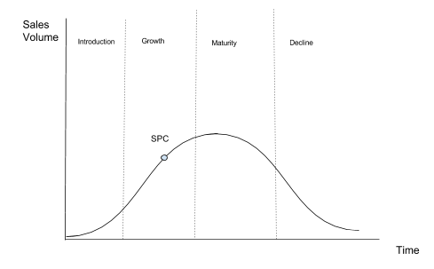

The figure above shows us the life-cycle for SPC. We can see that SPC is in the growth section of the life cycle. Being in the growth section correlates to a relatively low IDU.

* + 1. IDU spectrum

Since SPC is the growth part of the life cycle its IDU is relatively low. Below I place SPC on the IDU Spectrum.

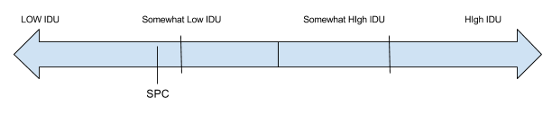

I decided to put them at somewhat low IDU due to being in the growth cycle. They also know when the peak season are which helps them predict when customer demand will be high for black and clear plastic containers.

* 1. **Step 2:**
     1. Establish the competitive strategy
        1. Based off the case study we can see the company has a differentiated strategy. We can show this in a 2x2 grid of “strategic target” and “source of competitive strategy”.

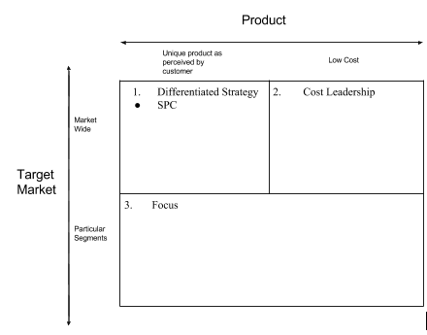

SPC sells clear plastic containers to grocery stores, bakeries, and restaurants and they sell black plastic containers to caterers and grocery stores. Thus, a differentiated strategy would be the best competitive strategy for this company. This is because they are selling two different products to several different markets.

* + 1. Trade-off between responsiveness/efficiency for the product based on the competitive strategy.
       1. SPC needs to be somewhat efficient due to their limited capacity on the extruders which requires them to build inventory of each type of sheet in anticipation of future demand.
    2. IDU Spectrum

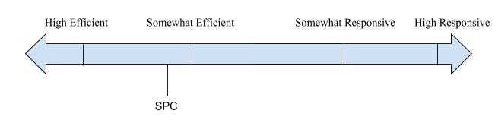

SPC was place at somewhat efficient on the IDU spectrum. This is due to it’s limited capacity on the extruders, forcing them to schedule and build inventory in advance. However, I din’t put it at the end of the spectrum because the company will have to store the extra containers resulting in a higher storage cost.

* 1. **Step 3:** 
     1. 2-D Space

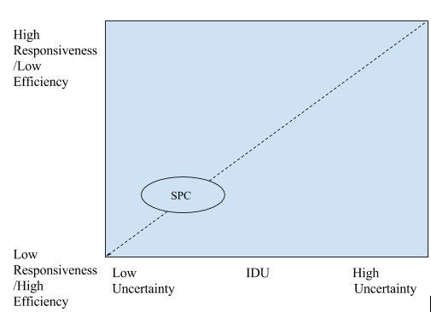

This 2-D space shows where SPC lies on a graph with the x-axis as the IDU and the y-axis as the responsiveness/efficiency. As we can see, SPC has both a low IDU and high efficiency.

* + 1. Define a zone of strategic fit.

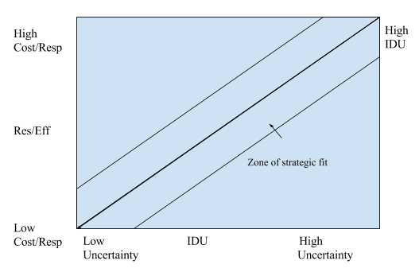

The above figure shows the zone of strategic fit. We will now show where SPC lies on this figure below.

* + 1. Map the SC strategy for the product in the zone of strategic fit.

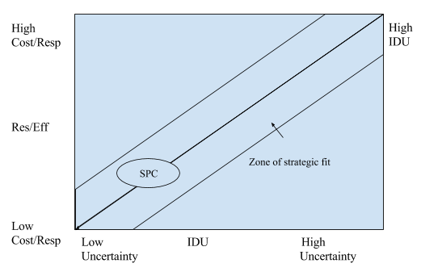

SPC’s optimal SC strategy is shown above. They should have a high efficiency/low and a low IDU. This is their best strategy due to them being in the growth part of their life cycle and their limited capacity on the extruders.

* 1. **Step 4:** 
     1. 5 Driver Diagram

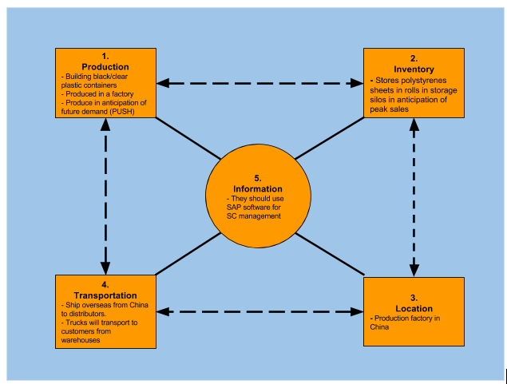

Explanation of drivers below

* + 1. Drivers explanation

|  |  |
| --- | --- |
| **SC Drivers** | **Details** |
| Production | SPC should produce their product in a factory. They should be using PUSH due to their limited capacity on the extruders. This will allow them to meet the customer demand during the peak periods. |
| Inventory | SPC stores their polystyrene sheets in rolls and saves them for future containers. This is their best strategy to meet peak demand. |
| Location | SPC should have their production factory in China. This is because China has one of the most efficient SC strategies. This makes them the best choice to produce the product at such a low cost. |
|
| Transportation | The products and supplies will be shipped from the manufacturing and storage facilities in China to the distributing facilities spread out across the U.S. using land and water transportation. |
| Information | We will use SAP’s supply chain management software in order to maintain our shipment and orders. This is because SAP leads in terms of ERP market share and is considered one of the best supply chain management software’s. |

1. **Draw Conclusions:**
   1. We found that SPC should have a differentiated competitive strategy. They should also have a somewhat low IDU and somewhat high efficiency. This seems to be their best option given their current status. If they were able to increase their capacity on the extruders they could shift to a more responsiveness strategy.

**Problem 3: Demand Forecasting For SPC**

1. **Define the Problem**
   1. Determine which forecasting method Julie should use for black plastic.
   2. Determine which forecasting method she should use for clear plastic.
   3. Determine the demand forecast for each quarter of 2007 for black plastic and for clear plastic.
2. **Create a Plan**
   1. **Step 1:** Use the static forecasting method for both black and clear plastic.
   2. **Step 2:** Use the Moving Average forecasting method for both black and clear plastic.
   3. **Step 3:** Use the Simple Exponential Smoothing forecasting method for both black and clear plastic.
   4. **Step 4:** Use the Holt’s Model forecasting method for both black and clear plastic.
   5. **Step 5:** Use the Winter’s Model forecasting method for both black and clear plastic.
   6. **Step 6:** Compare the different methods for the black plastic and determine which is the best.
   7. **Step 7:** Compare the different methods for the clear plastic and determine which is the best.
   8. **Step 8:** With the most accurate method determine what the demand forecast for each quarter of 2007 is for each plastic.
3. **Execute**
   1. **Step 1:** Static Forecasting

**Black Plastic Forecast**

Below is the quarterly demand data for black plastic. The first step is to estimate the level, trend, and seasonal factors. To do this we need to follow two steps.

1. Deseasonalize demand and run linear regression to estimate level and trend.
2. Estimate seasonal factors.

*Demand Data*

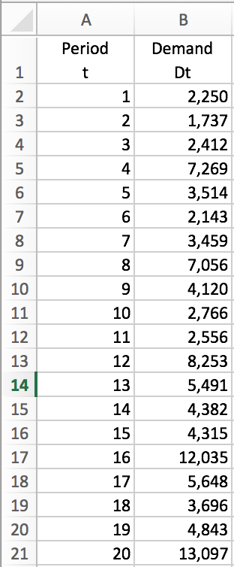

*Plotted Demand Data*

In this problem we have p=4 (We can see this in the figure above). To solve for t we need to solve for the median of D1:D4 and the median of D2:D5. This gives us D2.5 and D3.5. We then take the average of these which gives t=3. Now that we have variables p and t we can use the following equation in excel to solve for the deseasonalized demand. We will use this equation since our p is even, =(B2+B6+2*SUM(B3:B5))/8. This equation will be in cells C4:C19. This gives us the sheet below.

*Deaseasonalized Demand Column C*

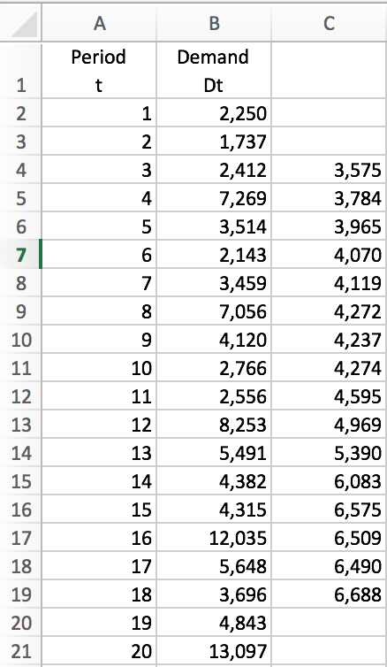

The values of L and T can then be estimated for the deseasonalized demand using linear regression with the deseasonalized demand in the figure above as the dependent variable and time as the independent variable. To do this I will use excel and go to data analysis|regression. My data for the Y Range will be C4:C19 and my X Range will be A4:A19. This gives me the results of the regression as shown below.

*Regression Summary Output*

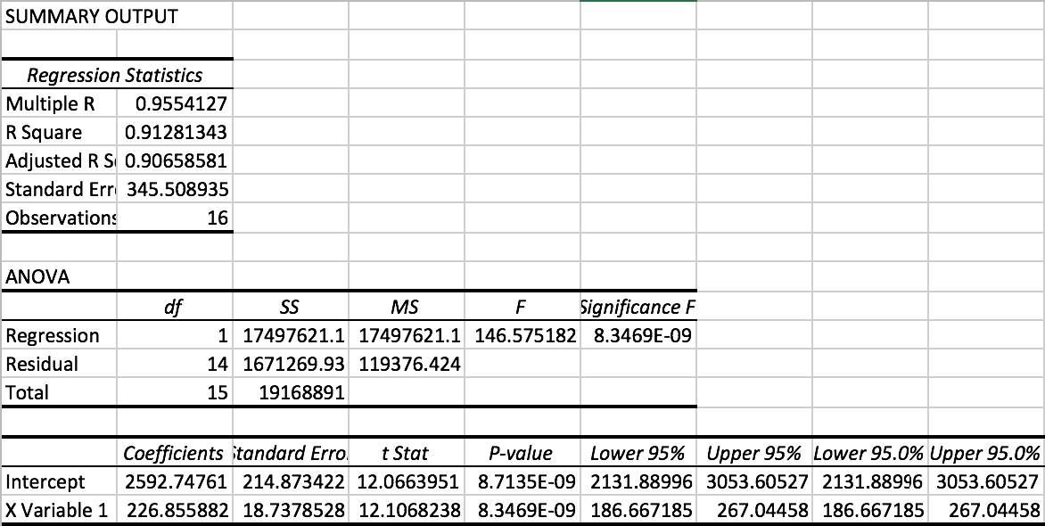

Initial level L is obtained as the intercept coefficient (2,593). T, the trend, is the X variable coefficient (227). With this we have the deseasonalized demand for any period t given by Dt=2,593+227t. We can now obtain the deseasonalized demand for peach period using this newly obtain equation. The completed deseasonalized demand is shown below.

*Completed Deseasonalized Demand*

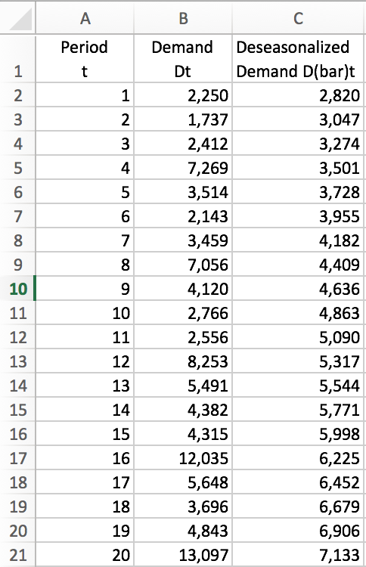

*Plotted Deseasonalized Demand*

The seasonal factor St for period t is the ratio of actual demand . The results of the seasonal factors is shown below.

*Seasonal Factors*

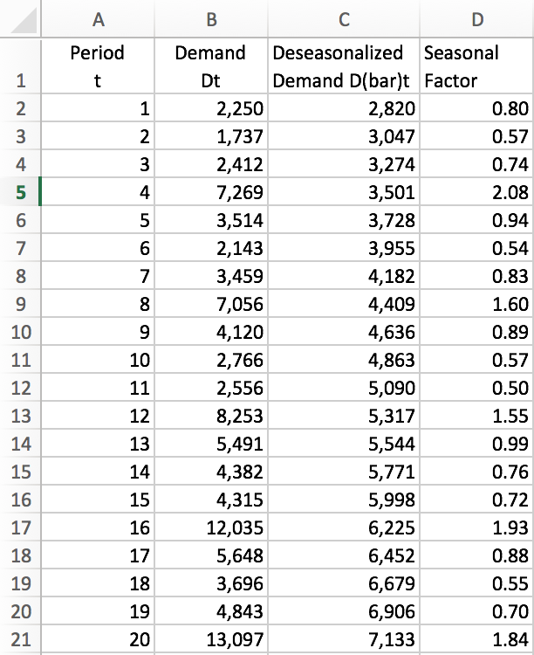

We now need to solve for the average seasonal factors St as shown below.

We can now obtain the forecast for the next four quarters. This is solved for below.

This is the forecast for the next four quarters for 2007 based off the equation found through this problem. We can now plot the forecasted data against the actual demand to see how they compare.

As we can see the forecasted demand seems to be fairly accurate, with some periods being a little off. Specifically, periods 11 and 14.

**Error Analysis for Black Plastic**

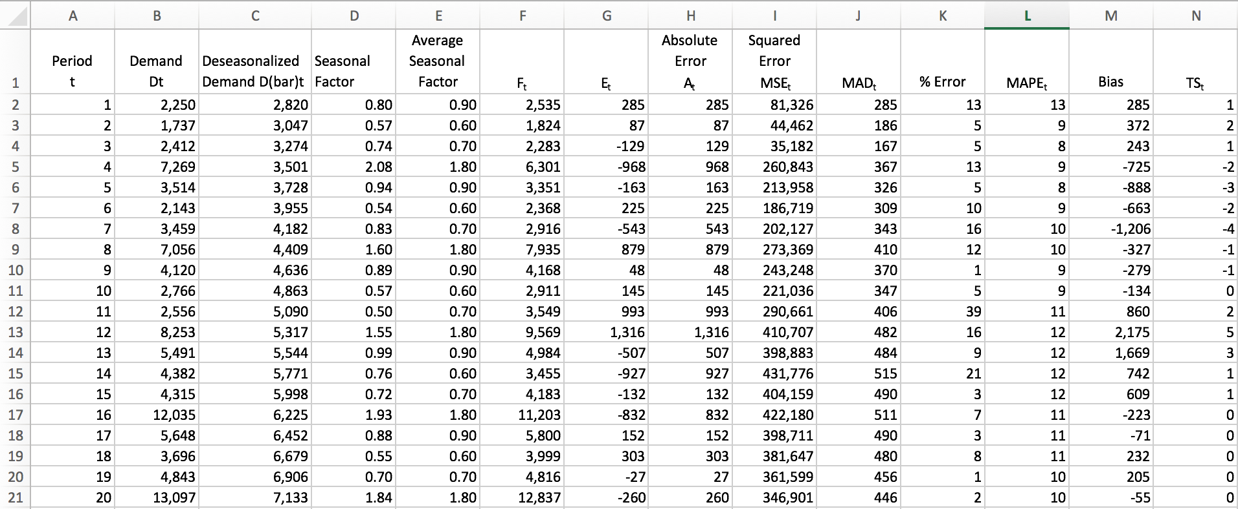

**Equations Used**

|  |  |  |
| --- | --- | --- |
| **Cell** | **Cell Formula** | **Copied to** |
| F2 | =(2593+A2*227)*E2 | F3:F21 |
| G2 | =F2-B2 | G3:G21 |
| H2 | =ABS(G2) | H3:H21 |
| I2 | =SUMSQ($G$2:G2)/(A2) | I3:I21 |
| J2 | =SUM($H$2:H2)/(A2) | J3:J21 |
| K2 | =100*(H2/B2) | K3:K21 |
| L2 | =AVERAGE($K$2:K2) | L3:L21 |
| M2 | =SUM($G$2:G2) | M3:M21 |
| N2 | =(M2/J2) | N3:N21 |

I was able to calculate all of the error data above with the equations shown in the table. This was possible once I obtained the forecasting data. The forecasting data was solved for using the regression equation and the average seasonal factors we solved for.

We can now plot some of the main error statistics, TS and MAPE.

As we can see the TS is well within the +-6 range, indicating that the forecast using static method does not contain any significant bias. We can also see that the MAPE isn’t too high. It looks like the highest amount of error was around periods 1, 11, and 14 which correlates to where our forecasted demand was a little off. Given that the MAD is 446, the estimate of standard deviation of forecast error, using a four-period moving average, is 1.25*446=558. This is low relative to the size of the forecast.

**Clear Plastic Forecast**

Below is the quarterly demand data for black plastic. The first step is to estimate the level, trend, and seasonal factors. To do this we need to follow two steps.

1. Deseasonalize demand and run linear regression to estimate level and trend.
2. Estimate seasonal factors.

*Demand Data*

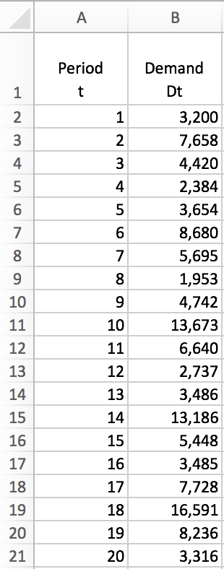

*Plotted Demand Data*

In this problem we have p=4 (We can see this in the figure above). To solve for t we need to solve for the median of D1:D4 and the median of D2:D5. This gives us D2.5 and D3.5. We then take the average of these which gives t=3. Now that we have variables p and t we can use the following equation in excel to solve for the deseasonalized demand. We will use this equation since our p is even, =(B2+B6+2*SUM(B3:B5))/8. This equation will be in cells C4:C19. This gives us the sheet below.

*Deaseasonalized Demand Column C*

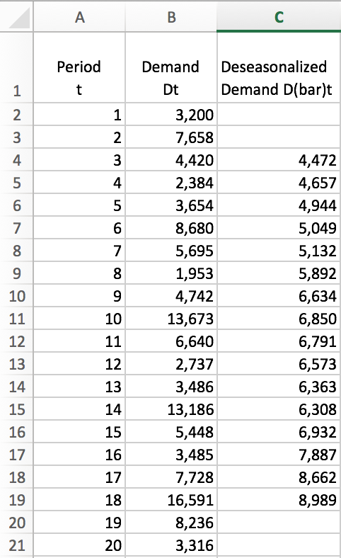

The values of L and T can then be estimated for the deseasonalized demand using linear regression with the deseasonalized demand in the figure above as the dependent variable and time as the independent variable. To do this I will use excel and go to data analysis|regression. My data for the Y Range will be C4:C19 and my X Range will be A4:A19. This gives me the results of the regression as shown below.

*Regression Summary Output*

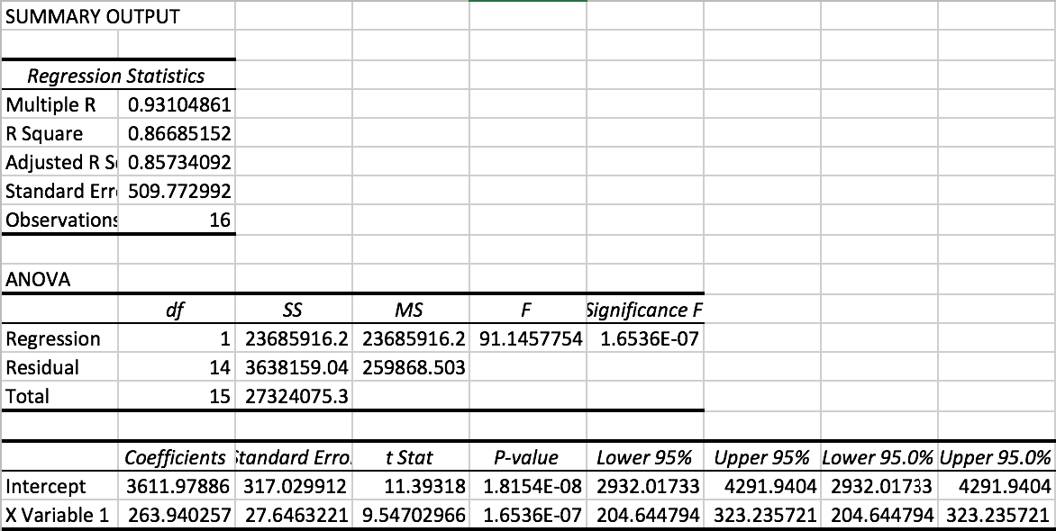

Initial level L is obtained as the intercept coefficient (3,612). T, the trend, is the X variable coefficient (264). With this we have the deseasonalized demand for any period t given by Dt=3,612+264t. We can now obtain the deseasonalized demand for peach period using this newly obtain equation. The completed deseasonalized demand is shown below.

*Completed Deseasonalized Demand*

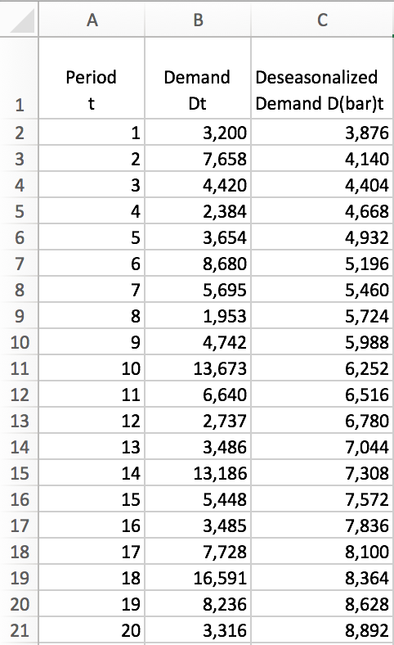

*Plotted Deseasonalized Demand*

The seasonal factor St for period t is the ratio of actual demand . The results of the seasonal factors is shown below.

*Seasonal Factors*

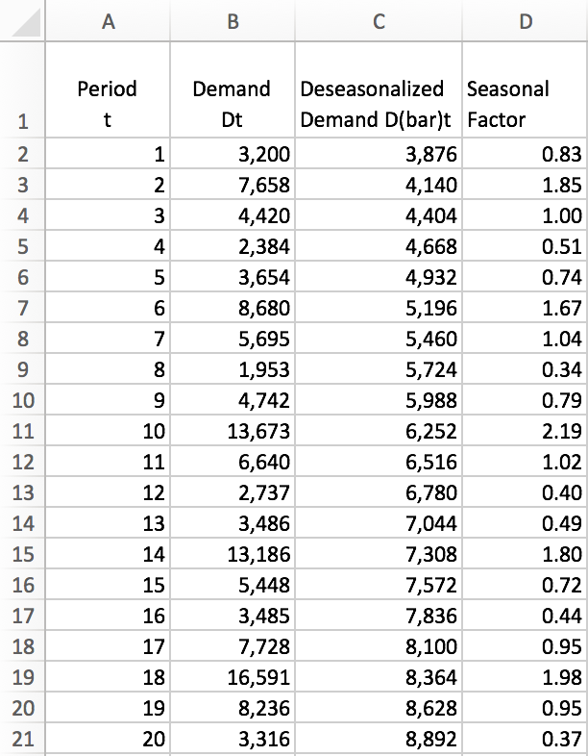

We now need to solve for the average seasonal factors St as shown below.

We can now obtain the forecast for the next four quarters. This is solved for below.

This is the forecast for the next four quarters for 2007 based off the equation found through this problem. We can now plot the forecasted data against the actual demand to see how they compare.

As we can see the forecasted demand seems to be a bit inaccurate. The forecasted data doesn’t seem to match up consistently. It follows the same trend but isn’t near the same values.

**Error Analysis for Clear Plastic**

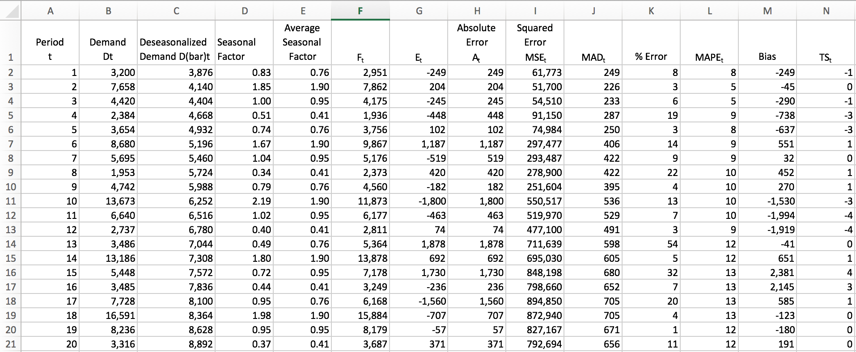

**Equations Used**

|  |  |  |
| --- | --- | --- |
| **Cell** | **Cell Formula** | **Copied to** |
| F2 | =(3612+A2*264)*E2 | F3:F21 |
| G2 | =F2-B2 | G3:G21 |
| H2 | =ABS(G2) | H3:H21 |
| I2 | =SUMSQ($G$2:G2)/(A2) | I3:I21 |
| J2 | =SUM($H$2:H2)/(A2) | J3:J21 |
| K2 | =100*(H2/B2) | K3:K21 |
| L2 | =AVERAGE($K$2:K2) | L3:L21 |
| M2 | =SUM($G$2:G2) | M3:M21 |
| N2 | =(M2/J2) | N3:N21 |

I was able to calculate all of the error data above with the equations shown in the table. This was possible once I obtained the forecasting data. The forecasting data was solved for using the regression equation and the average seasonal factors we solved for.

We can now plot some of the main error statistics, TS and MAPE.

As we can see the TS is well within the +-6 range, indicating that the forecast using static method does not contain any significant bias. We can also see that the MAPE isn’t too high. The graph shows that the forecasting error goes up as it goes further into the future. Given that the MAD is 656, the estimate of standard deviation of forecast error, using a four-period moving average, is 1.25*656=820. This is low relative to the size of the forecast.

* 1. **Step 2:** Moving Average

**Black Plastic Forecast**

In this method we assume the data only has level. The first step is to estimate the level in Period t. We need to choose the number of data points, N, for computing the moving average. In this problem we will be using N=4, a 4-point moving average. The equation for this is the following.



This can be translated to excel as =AVERAGE(B2:B5). The result is shown below.

*4-point Moving Average Level*

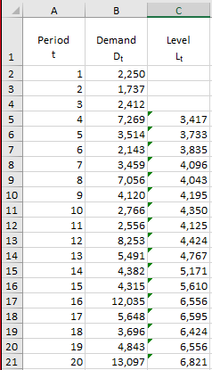

Now that we have the level we can determine the forecasting data. This is also shown below.

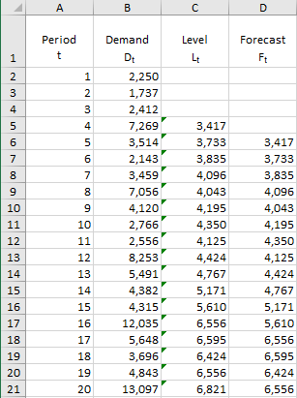

**Equations used:**

|  |  |  |
| --- | --- | --- |
| **Cell** | **Cell Formula** | **Copied to** |
| C5 | =AVERAGE(B2:B5) | C6:C21 |
| D6 | =C5 | D7:D21 |

*Actual and Forecasted Demand data*

**Error Analysis for Black Plastic**

To obtain the error data we plug in our forecasting and demand data into the excel sheet with the formulas we’ve used before. This shown below.

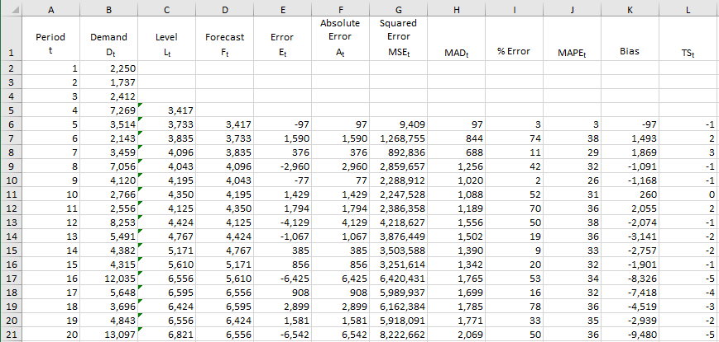

**Equations used:**

|  |  |  |
| --- | --- | --- |
| **Cell** | **Cell Formula** | **Copied to** |
| C5 | =AVERAGE(B2:B5) | C6:C21 |
| D6 | =C5 | D7:D21 |
| E6 | =D6-B6 | E7:E21 |
| F6 | =ABS(E6) | F7:F21 |
| G6 | =SUMSQ($E$6:E6)/(A6-4) | G7:G21 |
| H6 | =SUM($F$6:F6)/(A6-4) | H7:H21 |
| I6 | =100*(F6/B6) | I7:I21 |
| J6 | =AVERAGE($I$6:I6) | J7:J21 |
| K6 | =SUM(E$6:E6) | K7:K21 |
| L6 | =(K6/H6) | L7:L21 |

We can now plot some of the main error statistics, TS and MAPE.

The MAPE is substantially high in this scenario. It stays steady around 35-40% error. This shows that the forecasting data is a bit off. However, our TS is within the +-6 range indicating that the forecast using the four-period moving average does not contain any significant bias. Given that the MAD is 2,069, the estimate of standard deviation of forecast error, using a four-period moving average, is 1.25*2,069=2,586. This is fairly large relative to the size of the forecast.

**Clear Plastic Forecast**

In this method we assume the data only has level. The first step is to estimate the level in Period t. We need to choose the number of data points, N, for computing the moving average. In this problem we will be using N=4, a 4-point moving average. The equation for this is the following.



This can be translated to excel as =AVERAGE(B2:B5). The result is shown below.

*4-point Moving Average Level*

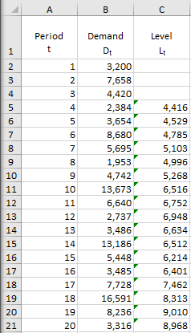

Now that we have the level we can determine the forecasting data. This is also shown below.

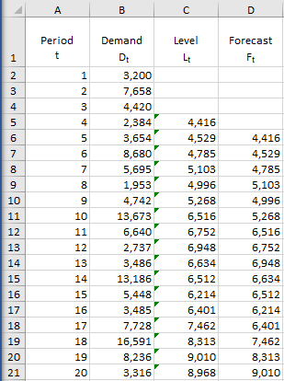

**Equations used:**

|  |  |  |
| --- | --- | --- |
| **Cell** | **Cell Formula** | **Copied to** |
| C5 | =AVERAGE(B2:B5) | C6:C21 |
| D6 | =C5 | D7:D21 |

*Actual and Forecasted Demand data*

Thus, using a four-period moving average, the forecast for Periods 21 through 24 is given by F21=F22=F23=F24=L20=8,968.

**Error Analysis for Clear Plastic**

To obtain the error data we plug in our forecasting and demand data into the excel sheet with the formulas we’ve used before. This is shown below.

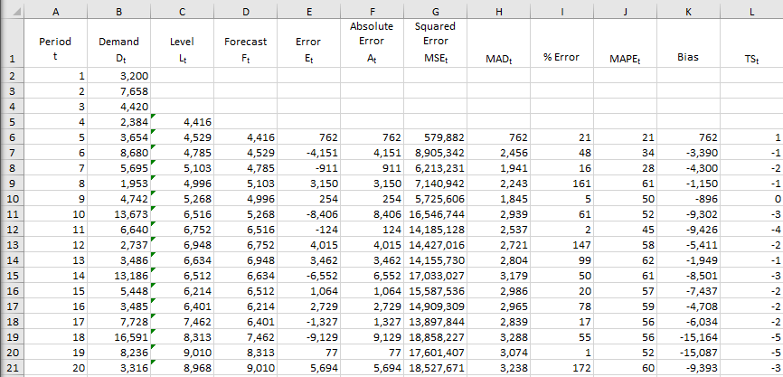

**Equations used:**

|  |  |  |
| --- | --- | --- |
| **Cell** | **Cell Formula** | **Copied to** |
| C5 | =AVERAGE(B2:B5) | C6:C21 |
| D6 | =C5 | D7:D21 |
| E6 | =D6-B6 | E7:E21 |
| F6 | =ABS(E6) | F7:F21 |
| G6 | =SUMSQ($E$6:E6)/(A6-4) | G7:G21 |
| H6 | =SUM($F$6:F6)/(A6-4) | H7:H21 |
| I6 | =100*(F6/B6) | I7:I21 |
| J6 | =AVERAGE($I$6:I6) | J7:J21 |
| K6 | =SUM(E$6:E6) | K7:K21 |
| L6 | =(K6/H6) | L7:L21 |

We can now plot some of the main error statistics, TS and MAPE.

The MAPE is substantially high in this scenario. It stays steady around 60% error. This shows that the forecasting data is not accurate. However, our TS is within the +-6 range indicating that the forecast using the four-period moving average does not contain any significant bias. Given that the MAD is 3,238, the estimate of standard deviation of forecast error, using a four-period moving average, is 1.25*3,238=4,048. This is fairly large relative to the size of the forecast.

* 1. **Step 3:** Simple Exponential Smoothing

**Black Plastic Forecasting**

In this method we assume that the data has only level, L. The first step is to find the initial level. This can be done by taking the average of all the demand points. I did this by using the equation =AVERAGE(B3:B14) which gave me the results below. This took the average of cells B3 through B14. We also need to solve for the rest of the levels. To do this we use the equation Lt=αDt+(1-α)Lo. This translated into excel is =0.06*B3+(1-0.06)*C2. The results are shown below.

*Level Data*

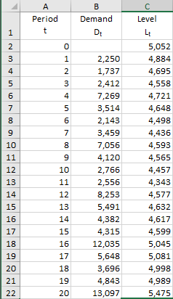

With all the levels we can now solve for the forecast which is Ft+1=Lt. The results are shown below.

*Forecast Data*

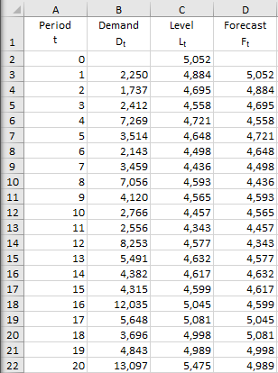

**Equations used:**

|  |  |  |
| --- | --- | --- |
| **Cell** | **Cell Formula** | **Copied to** |
| C2 | =AVERAGE(B3:B22) |  |
| C3 | =0.06*B3+(1-0.06)*C2 | C4:C22 |
| D3 | =C2 | D4:D22 |

The forecast data is given by the previous cell in column C. We can see by the plotted data that the forecasted and actual demand don’t match up. This shows how inaccurate the forecasted demand appears to be. using a four-period moving average, the forecast for Periods 21 through 24 is given by F21=F22=F23=F24=L20=5,475.

**Error Analysis for Black Plastic**

To obtain the error data we plug in our forecasting and demand data into the excel sheet with the formulas we’ve used before. This is shown below.

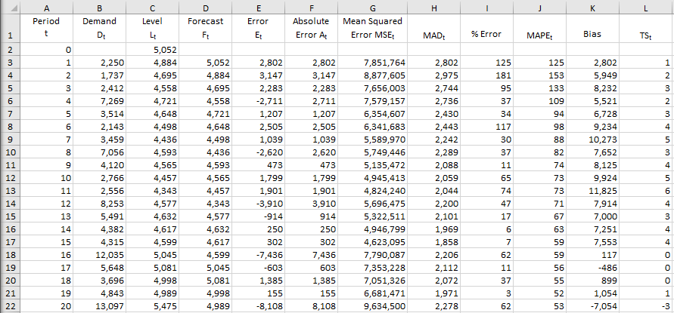

**Equations used:**

|  |  |  |
| --- | --- | --- |
| **Cell** | **Cell Formula** | **Copied to** |
| C2 | =AVERAGE(B3:B22) |  |
| C3 | =0.06*B3+(1-0.06)*C2 | C4:C22 |
| D3 | =C2 | D4:D22 |
| E3 | =D3-B3 | E4:E22 |
| F3 | =ABS(E3) | F4:F22 |
| G3 | =SUMSQ($E$3:E3)/(A3-4) | G4:G22 |
| H3 | =SUM($F$3:F3)/(A3-4) | H4:H22 |
| I3 | =100*(F3/B3) | I4:I22 |
| J3 | =AVERAGE($I$3:I3) | J4:J22 |
| K3 | =SUM(E$3:E3) | K4:K22 |
| L3 | =(K3/H3) | L4:L22 |

We can now plot some of the main error statistics, TS and MAPE.

The MAPE is substantially high in this scenario. It starts around 120% error, spiking to 160, then gradually decreasing to 40%. This shows that the forecasting data is not accurate. However, our TS is within the +-6 range indicating that the forecast using the simple exponential smoothing method does not contain significant bias. Given that the MAD is 2,278, the estimate of standard deviation of forecast error, using simple exponential smoothing method, is 1.25*2,278=2,848. This is large relative to the size of the forecast.

**Clear Plastic Forecast**

In this method we assume that the data has only level, L. The first step is to find the initial level. This can be done by taking the average of all the demand points. I did this by using the equation =AVERAGE(B3:B14) which gave me the results below. This took the average of cells B3 through B14. We also need to solve for the rest of the levels. To do this we use the equation Lt=αDt+(1-α)Lo. This translated into excel is =0.06*B3+(1-0.06)*C2. The results are shown below.

*Level Data*

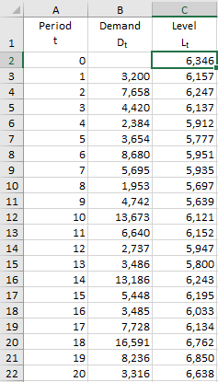

With all the levels we can now solve for the forecast which is Ft+1=Lt. The results are shown below.

*Forecast Data*

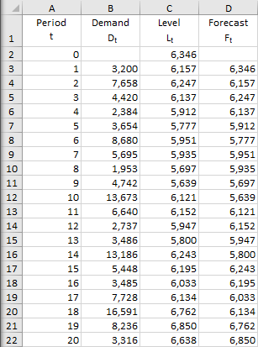

**Equations used:**

|  |  |  |
| --- | --- | --- |
| **Cell** | **Cell Formula** | **Copied to** |
| C2 | =AVERAGE(B3:B22) |  |
| C3 | =0.06*B3+(1-0.06)*C2 | C4:C22 |
| D3 | =C2 | D4:D22 |

The forecast data is given by the previous cell in column C. We can see by the plotted data that the forecasted and actual demand don’t match up. This shows how inaccurate the forecasted demand appears to be. using a four-period moving average, the forecast for Periods 21 through 24 is given by F21=F22=F23=F24=L20=6,638.

**Error Analysis for Clear Plastic**

To obtain the error data we plug in our forecasting and demand data into the excel sheet with the formulas we’ve used before. This is shown below.

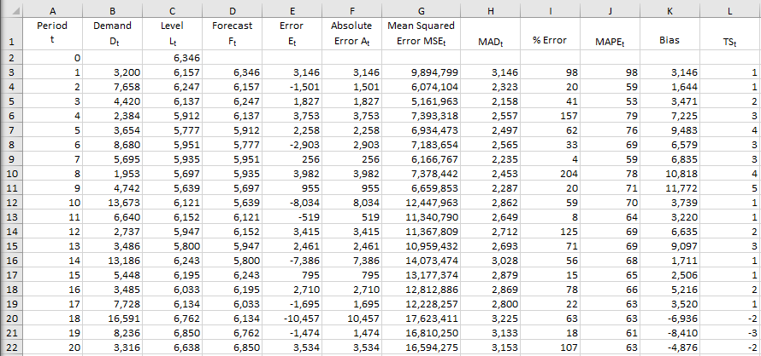

**Equations used:**

|  |  |  |
| --- | --- | --- |
| **Cell** | **Cell Formula** | **Copied to** |
| C2 | =AVERAGE(B3:B22) |  |
| C3 | =0.06*B3+(1-0.06)*C2 | C4:C22 |
| D3 | =C2 | D4:D22 |
| E3 | =D3-B3 | E4:E22 |
| F3 | =ABS(E3) | F4:F22 |
| G3 | =SUMSQ($E$3:E3)/(A3-4) | G4:G22 |
| H3 | =SUM($F$3:F3)/(A3-4) | H4:H22 |
| I3 | =100*(F3/B3) | I4:I22 |
| J3 | =AVERAGE($I$3:I3) | J4:J22 |
| K3 | =SUM(E$3:E3) | K4:K22 |
| L3 | =(K3/H3) | L4:L22 |

We can now plot some of the main error statistics, TS and MAPE.

The MAPE is substantially high in this scenario. It starts around 100% error and gradually decreases to 70%. This shows that the forecasting data is not accurate. However, our TS is within the +-6 range indicating that the forecast using the simple exponential smoothing method does not contain significant bias. Given that the MAD is 3,153, the estimate of standard deviation of forecast error, using the simple exponential smoothing method, is 1.25*3,153=3,941. This is large relative to the size of the forecast.

* 1. **Step 4:** Holt’s Model

**Black Plastic Forecasting**

Systematic component of demand in this case is given by the sum of the level and trend. The first step is to estimate the level at Period 0 and the initial trend. We can obtain this estimate by running a linear regression between demand, Dt, and time, Period t. The result is shown below. As shown, the L0 = 2,043 (intercept coefficient) and T0 = 287 (X variable coefficient).

*Regression Results*

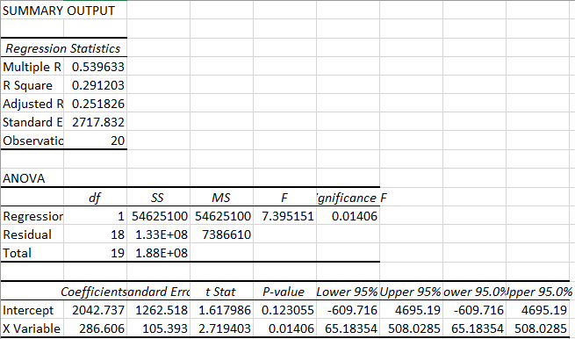

We will now apply Holt’s model with α = 0.06 and β = 0.06 to obtain the forecast for each of the 20 periods for which demand data are available. We can make the forecast using equation and . The level is updated using the equation . The trend can be updated using the equation . The translated excel equations are shown in a table below the results.

*Level, trend, and forecast results*

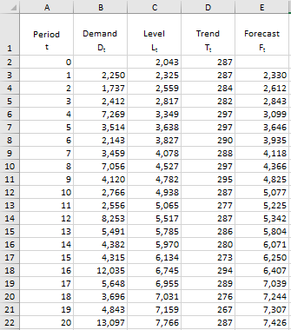

**Equations plugged into the table:**

|  |  |  |
| --- | --- | --- |
| **Cell** | **Cell Formula** | **Copied To** |
| C2 | =0.06*B3+(1-0.06)*(C2+D2) | C3:22 |
| D2 | =0.06*(C3-C2)+(1-0.06)*D2 | D3:D22 |
| E2 | =C2+D2 | E3:E22 |

The forecasted demand appears to increase along with actual demand. The Level for period 20 is 7,766 and the trend for period 20 is 287. With this data we can solve for the next four periods. This is shown below.

**Error Analysis for Black Plastic**

To obtain the error data we plug in our forecasting and demand data into the excel sheet with the formulas we’ve used before. This is shown below.

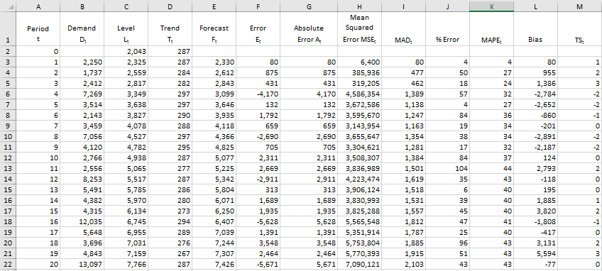

**Equations plugged into the table:**

|  |  |  |
| --- | --- | --- |
| **Cell** | **Cell Formula** | **Copied To** |
| C2 | =0.06*B3+(1-0.06)*(C2+D2) | C3:C22 |
| D2 | =0.06*(C3-C2)+(1-0.06)*D2 | D3:D22 |
| E2 | =C2+D2 | E3:E22 |
| F2 | =E3-B3 | F3:F22 |
| G2 | =ABS(F3) | G3:G22 |
| H2 | =SUMSQ($F$3:F3)/A3 | H3:H22 |
| I2 | =SUM($G$3:G3)/A3 | I3:I22 |
| J2 | =100*(G3/B3) | J3:J22 |
| K2 | =AVERAGE($J$3:J3) | K3:K22 |
| L2 | =SUM($F$3:F3) | L3:L22 |
| M2 | =(L3/I3) | M3:M22 |

We can now plot some of the main error statistics, TS and MAPE.

The MAPE is high in this scenario. It starts around 5% error and increases to 45%. This shows that the forecasting data is not accurate. However, our TS is within the +-6 range indicating that the forecast using Holt’s method does not contain significant bias. Given that the MAD is 2,103, the estimate of standard deviation of forecast error, using Holt’s method with α=0.06 and β=0.06, is 1.25*2,103=2,629. This is large relative to the size of the forecast.

**Clear Plastic Forecasting**

Systematic component of demand in this case is given by the sum of the level and trend. The first step is to estimate the level at Period 0 and the initial trend. We can obtain this estimate by running a linear regression between demand, Dt, and time, Period t. The result is shown below. As shown, the L0 = 4,134 (intercept coefficient) and T0 = 211 (X variable coefficient).

*Regression Results*

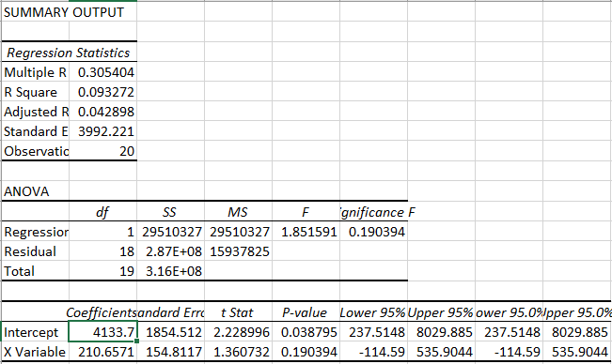

We will now apply Holt’s model with α = 0.06 and β = 0.06 to obtain the forecast for each of the 20 periods for which demand data are available. We can make the forecast using equation and . The level is updated using the equation . The trend can be updated using the equation . The translated excel equations are shown in a table below the results.

*Level, trend, and forecast results*

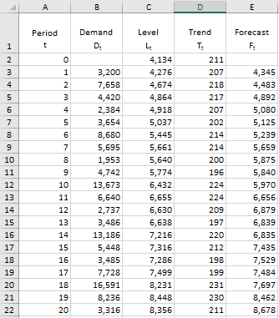

**Equations plugged into the table:**

|  |  |  |
| --- | --- | --- |
| **Cell** | **Cell Formula** | **Copied To** |
| C2 | =0.06*B3+(1-0.06)*(C2+D2) | C3:22 |
| D2 | =0.06*(C3-C2)+(1-0.06)*D2 | D3:D22 |
| E2 | =C2+D2 | E3:E22 |

The forecasted demand appears to increase along with actual demand. The Level for period 20 is 8,356 and the trend for period 20 is 211. With this data we can solve for the next four periods. This is shown below.

**Error Analysis for Clear Plastic**

To obtain the error data we plug in our forecasting and demand data into the excel sheet with the formulas we’ve used before. This is shown below.

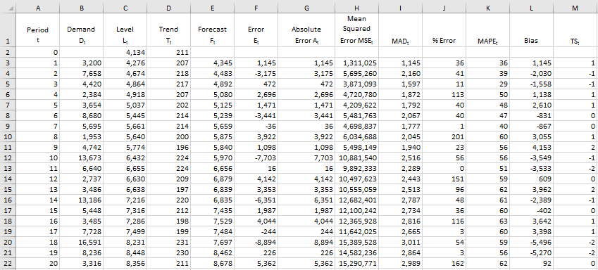

**Equations plugged into the table:**

|  |  |  |
| --- | --- | --- |
| **Cell** | **Cell Formula** | **Copied To** |
| C2 | =0.06*B3+(1-0.06)*(C2+D2) | C3:C22 |
| D2 | =0.06*(C3-C2)+(1-0.06)*D2 | D3:D22 |
| E2 | =C2+D2 | E3:E22 |
| F2 | =E3-B3 | F3:F22 |
| G2 | =ABS(F3) | G3:G22 |
| H2 | =SUMSQ($F$3:F3)/A3 | H3:H22 |
| I2 | =SUM($G$3:G3)/A3 | I3:I22 |
| J2 | =100*(G3/B3) | J3:J22 |
| K2 | =AVERAGE($J$3:J3) | K3:K22 |
| L2 | =SUM($F$3:F3) | L3:L22 |
| M2 | =(L3/I3) | M3:M22 |

We can now plot some of the main error statistics, TS and MAPE.

The MAPE is high in this scenario. It starts around 35% error and increases to 60%. This shows that the forecasting data is not accurate. However, our TS is within the +-6 range indicating that the forecast using Holt’s Method does not contain significant bias. Given that the MAD is 2,989, the estimate of standard deviation of forecast error, using Holt’s method with α=0.06 and β=0.06, is 1.25*2,989=2,736. This is fairly large relative to the size of the forecast.

* 1. **Step 5:** Winter’s Model

**Black Plastic Forecasting**

The first step is to estimate the level and trend for Period 0, and seasonal factors for Periods 1 through p=4. To start this, we need to deseasonalize the demand. Then we can run a regression between deseasonalized demand and time. We have this part done from the static method we performed in in step 1.. The final result is shown below.

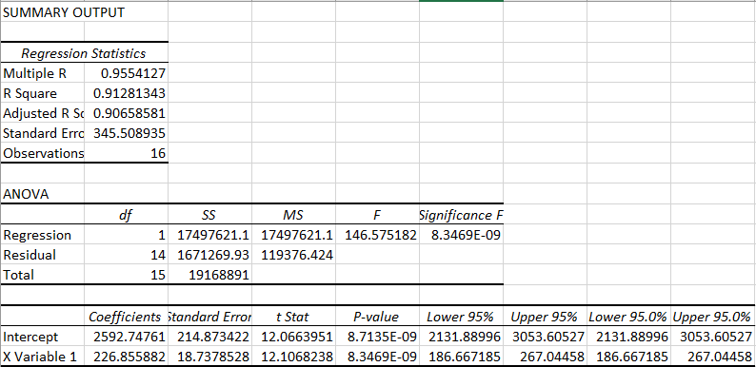

We will use the intercept coefficient 2,593 as our Lo and the X variable coefficient 227 as our To. We also have the seasonal factors solved from the static method so we can use those values as well. We can now apply Winter’s model with α=0.06, β=0.06 and γ=0.06 to obtain forecasts. The forecast is made using equation and . The level is updated using the equation . The trend is updated using equation . The seasonal factors are updated using the equation .

*Trend and Seasonality-Corrected Exponential Smoothing Results*

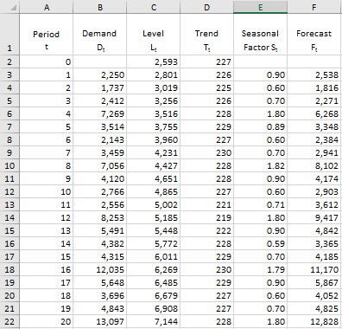

|  |  |  |
| --- | --- | --- |
| **Cell** | **Cell Formula** | **Copied To** |
| C2 | =0.06*(B3/E3)+(1-0.06)*(C2+D2) | C3:22 |
| D2 | =0.06*(C3-C2)+(1-0.06)*D2 | D3:D22 |
| E7 | =0.06*(B3/C3)+(1-0.06)*E3 | E7:E22 |
| F2 | =(C2+D2)*E3 | F3:F22 |

From a look at the plotted data we can see that the forecasted data is fairly accurate. However, there appear to be a few periods where the data is off. We have L22=7,144, T22=228, S23=0.90, S24=0.60, S25=0.70, S26=1.80. Now with this data we can solve for the future forecast as shown below.

**Error Analysis for Black Plastic**

To obtain the error data we plug in our forecasting and demand data into the excel sheet with the formulas we’ve used before. This is shown below.

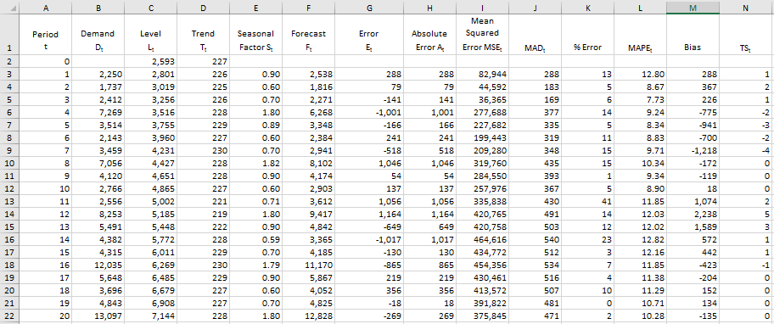

**Equations plugged into the table:**

|  |  |  |
| --- | --- | --- |
| **Cell** | **Cell Formula** | **Copied To** |
| C2 | =0.06*(B3/E3)+(1-0.06)*(C2+D2) | C3:22 |
| D2 | =0.06*(C3-C2)+(1-0.06)*D2 | D3:D22 |
| E7 | =0.06*(B3/C3)+(1-0.06)*E3 | E7:E22 |
| F2 | =(C2+D2)*E3 | F3:F22 |
| G2 | =F3-B3 | G3:G22 |
| H2 | =ABS(G3) | H3:H22 |
| I2 | =SUMSQ($G$3:G3)/A3 | I3:I22 |
| J2 | =SUM($H$3:H3)/A3 | J3:J22 |
| K2 | =100*(H3/B3) | K3:K22 |
| L2 | =AVERAGE($K$3:K3) | L3:L22 |
| M2 | =SUM($G$3:G3) | M3:M22 |
| N2 | =M3/J3 | N3:N22 |

We can now plot some of the main error statistics, TS and MAPE.

The MAPE is very low compared to the other methods. It stays around 13%. This shows that the forecasting data is fairly accurate. Our TS is also within the +-6 range indicating that the forecast using Winter’s Method does not contain significant bias. Given that the MAD is 471, the estimate of standard deviation of forecast error, using Winter’s method with α=0.06 and β=0.06, and γ=0.06 is 1.25*471=589. This is fairly low relative to the size of the forecast.

**Clear Plastic Forecasting**

The first step is to estimate the level and trend for Period 0, and seasonal factors for Periods 1 through p=4. To start this, we need to deseasonalize the demand. Then we can run a regression between deseasonalized demand and time. We have this part done from the static method we performed in in step 1. The final result is shown below.

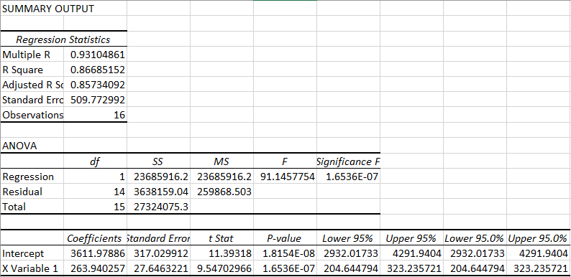

We will use the intercept coefficient 3,612 as our Lo and the X variable coefficient 264 as our To. We also have the seasonal factors solved from the static method so we can use those values as well. We can now apply Winter’s model with α=0.06, β=0.06 and γ=0.06 to obtain forecasts. The forecast is made using equation and . The level is updated using the equation . The trend is updated using equation . The seasonal factors are updated using the equation .

*Trend and Seasonality-Corrected Exponential Smoothing Results*

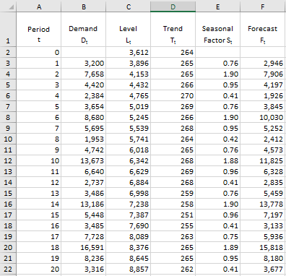

|  |  |  |
| --- | --- | --- |
| **Cell** | **Cell Formula** | **Copied To** |
| C2 | =0.06*(B3/E3)+(1-0.06)*(C2+D2) | C3:22 |
| D2 | =0.06*(C3-C2)+(1-0.06)*D2 | D3:D22 |
| E7 | =0.06*(B3/C3)+(1-0.06)*E3 | E7:E22 |
| F2 | =(C2+D2)*E3 | F3:F22 |

From a look at the plotted data we can see that the forecasted data is fairly accurate. However, there appear to be a few periods where the data is off. We have L22=8,857, T22=262, S23=0.76, S24=1.90, S25=0.95, S26=0.41. Now with this data we can solve for the future forecast as shown below.

**Error Analysis for Clear Plastic**

To obtain the error data we plug in our forecasting and demand data into the excel sheet with the formulas we’ve used before. This is shown below.

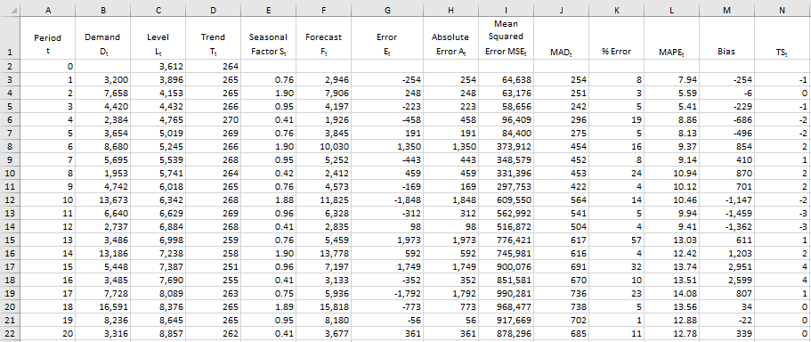

**Equations plugged into the table:**

|  |  |  |
| --- | --- | --- |
| **Cell** | **Cell Formula** | **Copied To** |
| C2 | =0.06*(B3/E3)+(1-0.06)*(C2+D2) | C3:22 |
| D2 | =0.06*(C3-C2)+(1-0.06)*D2 | D3:D22 |
| E7 | =0.06*(B3/C3)+(1-0.06)*E3 | E7:E22 |
| F2 | =(C2+D2)*E3 | F3:F22 |
| G2 | =F3-B3 | G3:G22 |
| H2 | =ABS(G3) | H3:H22 |
| I2 | =SUMSQ($G$3:G3)/A3 | I3:I22 |
| J2 | =SUM($H$3:H3)/A3 | J3:J22 |
| K2 | =100*(H3/B3) | K3:K22 |
| L2 | =AVERAGE($K$3:K3) | L3:L22 |
| M2 | =SUM($G$3:G3) | M3:M22 |
| N2 | =M3/J3 | N3:N22 |

We can now plot some of the main error statistics, TS and MAPE.

The MAPE is very low compared to the other methods. It starts around 8% and gradually increases to around 13%. This shows that the forecasting data is fairly accurate. Our TS is also within the +-6 range indicating that the forecast using Winter’s Method does not contain significant bias. Given that the MAD is 685, the estimate of standard deviation of forecast error, using Winter’s method with α=0.06 and β=0.06, and γ=0.06 is 1.25*685=856. This is fairly low relative to the size of the forecast.

* 1. **Step 6:** Black Plastic Comparison

|  |  |  |  |
| --- | --- | --- | --- |
| **Forecasting Method** | **MAD** | **MAPE(%)** | **TS Range** |
| Static | 446 | 10 | -4 to 5 |
| Four-period moving average | 2,069 | 36 | -5 to 3 |
| Simple exponential smoothing | 2,278 | 53 | -3 to 6 |
| Holt’s model | 2,103 | 43 | -2 to 3 |
| Winter’s model | 471 | 10 | -4 to 5 |

We can see from the comparison table above that the three models four-period moving average, simple exponential smoothing, and Holt’s model, do not compare to the static and Winter’s method. The static and Winter’s method are very similar with just a difference in their MAD. Based off of the data I would have to say that the static method is slightly more accurate.

* 1. **Step 7:** Clear Plastic Compariso

|  |  |  |  |
| --- | --- | --- | --- |
| **Forecasting Method** | **MAD** | **MAPE(%)** | **TS Range** |
| Static | 656 | 12 | -4 to 4 |
| Four-period moving average | 3,238 | 60 | -5 to 1 |
| Simple exponential smoothing | 3,153 | 63 | -3 to 5 |
| Holt’s model | 2,989 | 62 | -2 to 2 |
| Winter’s model | 685 | 13 | -3 to 4 |

We can see from the comparison table above that the three models four-period moving average, simple exponential smoothing, and Holt’s model, do not compare to the static and Winter’s method. The static and Winter’s method are very similar with a small difference in their MAD. Based off of the data I would have to say that the static method is slightly more accurate.

* 1. **Step 8:** Demand forecast for each quarter of 2007
     1. **Black Plastic:** We solved for the forecasted values earlier in the problem.
     2. **Clear Plastic:** We solved for the forecasted values earlier in the problem.

1. **Draw Conclusions**
   1. After performing all of the methods I found that the only two accurate ones for both scenarios was Winter’s method and Static method. The most accurate of the two was static. The other three were completely off and shouldn’t be considered. By using the static forecasting method I have that the data for each quarter of 2007 is 6,624, 4,552, 5,470, and 14,474 for black plastic and 6,959, 17,898, 9,200, 4,079 for clear plastic.

**Problem 4: Cycle Inventory for Polystyrene at SPC**

1. **Define the Problem:** 
   1. Why should SPC have a cycle inventory? SPC buys polystyrene resin from a supplier in 1000-pound units, and each unit costs $20.00, and the percent holding cost is 10%. The fixed shipping cost per order is $300. If we assume that 1000 pounds of resin yields 1000 pounds of clear plastic, what are the following values for clear plastic.
      1. Lot size per shipment to minimize total cost
         1. To solve for this value we need to use the equation .
      2. Economic order quantity (EOQ)
      3. Number of shipments/year for polystyrene resin in order to meet the forecasted demand for clear plastic in 2007.
      4. Cycle inventory
      5. Cycle inventory holding cost
      6. Replenishment cycle time
      7. Average flow time.
   2. Use a diagram showing clear plastic inventory as a function of time to illustrate these values.
   3. Read the section in the SCM text on Short-Term Discounting(SCM, Third Edition, Section 10.4 or Fourth Edition, Section 10.5), and then answer the following question. If the supplier offers a promotional discount of 25% per unit at the beginning of the year, what is the optimal order quantity, and how much should the forward buy on polystyrene be?
2. **Create a Plan:**
   1. **Step 1:** Explain why SPC should have a cycle inventory.
   2. **Step 2:**  Solve for the following values for clear plastic.
      1. Lot size per shipment to minimize total cost
      2. Economic order quantity (EOQ)
      3. Number of shipments/year for polystyrene resin in order to meet the forecasted demand for clear plastic in 2007.
      4. Cycle inventory
      5. Cycle inventory holding cost
      6. Replenishment cycle time
      7. Average flow time.
   3. **Step 3:** Create a diagram with the values found in step 2
   4. **Step 4:** Read the section in the SCM text. Determine what the optimal order quantity is with a promotional discount of 25%. Also, determine how much the forward buy on polystyrene should be.
3. **Execute:**
   1. **Step 1:** SPC should have a cycle inventory because their demand for each product changes drastically based on the time of the year. A cycle inventory keeps track of inventory constantly rather than once a year. Cycle inventory is the average inventory in a supply chain due to either production or purchases in lot sizes that are larger than those demanded by the customer. This works perfectly for SPC since they must stock more than the current demand. SPC has to stock extra to meet the peak in demand due to its limited capacity on the extruders.
   2. **Step 2:** 
      1. Lot size per shipment to minimize total cost
         1. (This value was solved for by taking the average of the annual demand for years 2002 through 2006)
         2. So with these values we have
      2. Economic order quantity (EOQ)
         1. (This value was solved for by taking the average of the annual demand for years 2002 through 2006)
         2. So with these values we have
      3. Number of shipments/year for polystyrene resin in order to meet the forecasted demand for clear plastic in 2007.
         1. The forecasted data for 2007 using the static method is the following
         2. With the forecasted data we can calculate the annual demand as .
         3. Now we can calculate the number of shipments/year for polystyrene in order to meet this demand as . In this case it would be . The final value would be rounded up to 14 shipments per year.
      4. Cycle inventory
         1. The cycle inventory equation is .
         2. So
      5. Cycle inventory holding cost
         1. In our case this would be $2,760
      6. Replenishment cycle time
         1. We can solve for this by dividing the amount of days in a year (365) by the value we found in iii) (number of shipments per year).
         2. This would be
      7. Average flow time.
         1. .
         2. In this case we have
   3. **Step 3:** Diagram

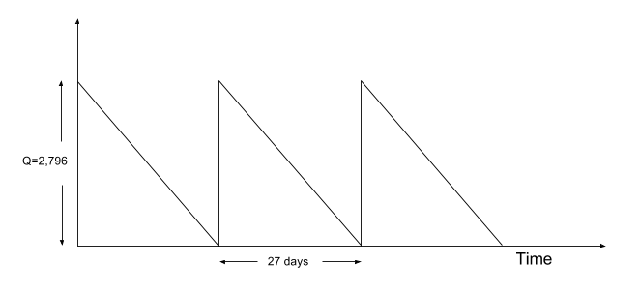

* 1. **Step 4:** Optimal order quantity with 25% discount.
     1. The equation to find the optimal order quantity at the discounted price is given by .
     2. By plugging in our values we have
     3. We also need to solve for the forward buy which is calculated as the following .
     4. By plugging in the values we have

1. **Draw Conclusions:**
   1. I had trouble figuring out some of the equations because I mixed up the meanings. I wasn’t sure about some of my answers until I read through chapter ten in the textbook more thoroughly. In the end I was able to come to a concrete answer for each of the sub-sections.

**Problem 5: Safety Inventory for Polystyrene Resin at SPC**

1. **Define the Problem:**
   1. Should SPC have a safety inventory? Why? How much safety inventory would you recommend for SPC?
2. **Create a Plan:**
   1. **Step 1:** Give a common sense answer.
3. **Execute:**
   1. **Step 1:**
      1. Yes SPC should have a safety inventory because of the limited capacity on their extruders. This limitation forces them to stock up in order to meet peak demand periods. By having a safety inventory they can prevent any lost orders and lost profits in case the peak of demand is too much. I would recommend SPC to hold about 10% of their quarterly demand in case of any problems. Too much safety inventory would result in too high of costs and defeat the purpose.
4. **Draw Conclusions:**
   1. In conclusion SPC should have a safety inventory. To make this decision I based it off what I believe is the safest move for the company. I used the facts that were presented in the case study.

**Problem 6: Execution of Your Plan**

1. **Define the Problem:**
   1. Using a table compare your plan from Problem 1 (column 1) with its execution (column 2). Indicate the reasons for the difference between the plan and its execution (column 3). Add at least one more column. What should column 4 contain.
2. **Create a Plan:**
   1. **Step 1:** Create a table to compare the plan from problem 1 with its execution.
3. **Execute:**
   1. **Step 1:** Table

|  |  |  |  |  |
| --- | --- | --- | --- | --- |
| **Problem** | **Plan** | **Execution** | **Reasons for Difference** | **What could you have done better?** |
| Reading | I planned to have this part done by 2/9/17 | I was able to finish the reading on time | No difference. | Nothing |
| 1 | I planned to have this part done by 2/9/17 | I was able to complete it in the planned time. | No difference. | I could have been a bit more careful and reasonable with my plan. I set my goals too early and I wasn’t able to finish them on time. |
| 2 | I planned to have this part done by 2/9/17 | I wasn’t able to finish this until 2/11/17. | I wasn’t able to start as early as I had liked due to work taking up more time than I had anticipated. | I should have taken into account my work schedule and planned accordingly. |
| 3 | I planned to have this part done by 2/10/17 | I wasn’t able to finish this until 2/11/17. | Due to pushing back problem 2 from work, I wasn’t able to start this on time. | I should have taken into account my work schedule and planned accordingly. |
| 4 | I planned to have this part done by 2/11/17 | I wasn’t able to finish this until 2/13/17 | I wasn’t able to finish this problem on time because I ran into issues with trying to solve for the values. I wasn’t sure of my work and I had to take more time than I thought reading through the book. | I should have re-read through chapter ten prior to starting the problem to give me a better understanding of the problem. |
| 5 | I planned to have this part done by 2/11/17 | I wasn’t able to finish this until 2/13/17 | I was set back by problem 4 and couldn’t finish this on the planned date. | I should have spread out my finishing dates for each problem. |
| 6 | I planned to have this part done by 2/11/17 | I wasn’t able to finish this until 2/13/17 | I was set back by problem 4 and couldn’t finish this on the planned date. | I should have spread out my finishing dates for each problem. |

1. **Draw Conclusions:**
   1. After doing this chart I realized that not all plans will be perfect. There will be hiccups in the plan and you have to be able to adapt accordingly. This is what determines whether the end product will be good.